Deliverable 1 Modified Scenarios

Xusheng Xiao

000954996

xxiao2@ncsu.edu

# Step 1

Following are sub-scenarios extracted from the problem scenario:

* Sub-scenario 1: MedRes and customer negotiate, and may agree to exchange medical equipment for certain price. *Commercial transaction* pattern models this scenario.
* Sub-scenario 2: MedRes places an order to MedEq and MedEq ships the equipment to customer. *Commercial transaction* pattern models this scenario.
* Sub-scenario 3: MedEq employs a shipper to ship the order (medical equipment) to the customer. *Outsourcing* pattern models this sub-scenario.
* Sub-scenario 4: MedEq buys replenishment stock from a contract manufacturer at a certain price. *Commercial transaction* pattern models this sub-scenario.
* Sub-scenario 5: The contract manufacturer employs a shipper to ship the order (medical equipment) to MedEq. *Outsourcing* pattern models this sub-scenario.
* Sub-scenario 6: Customer requests a support service and MedRes provides the support service for repairing equipment. *Standing service contract* pattern models this scenario.

# Step 2

Following are the roles and the agents adopting those roles for each of the sub-scenarios:

* Sub-scenario 1:

|  |  |
| --- | --- |
| Role | Agent |
| Company | MedRes |
| Customer | A customer of MedRes |

* Sub-scenario 2:

|  |  |
| --- | --- |
| Role | Agent |
| Company | MedRes |
| Customer | A customer of MedEq |
| EqComp | MedEq |

* Sub-scenario 3:

|  |  |
| --- | --- |
| Role | Agent |
| EqComp | MedEq |
| Customer | A customer of MedEq |
| Shipper 1 | FedUp, UpFed |

* Sub-scenario 4:

|  |  |
| --- | --- |
| Role | Agent |
| EqComp | MedEq |
| Manufacturer | FlexMan, SoleMan |

* Sub-scenario 5:

|  |  |
| --- | --- |
| Role | Agent |
| EqComp | MedEq |
| Manufacturer | FlexMan, SoleMan |
| Shipper 2 | A shipper that the manufacturer employs for shipping the order to  MedEq |

* Sub-scenario 6:

|  |  |
| --- | --- |
| Role | Agent |
| Company | MedRes |
| Customer | A customer of MedRes |

# Step 3

Following are the business tasks executed by each role:

* Sub-scenario 1:

|  |  |
| --- | --- |
| Role | Task |
| Company | goodsCust |
| Customer | payComp |

* Sub-scenario 2:

|  |  |
| --- | --- |
| Role | Task |
| Company | payEq |
| EqComp | goodsCust |

* Sub-scenario 3:

|  |  |
| --- | --- |
| Role | Task |
| EqComp | goodsCust, payShip1 |
| Customer |  |
| Shipper 1 | goodsCust |

* Sub-scenario 4:

|  |  |
| --- | --- |
| Role | Task |
| EqComp | payMfg |
| Manufacturer | goodsComp |

* Sub-scenario 5:

|  |  |
| --- | --- |
| Role | Task |
| EqComp |  |
| Manufacturer | goodsComp, payShip2 |
| Shipper 2 | goodsComp |

* Sub-scenario 6:

|  |  |
| --- | --- |
| Role | Task |
| Company | service |
| Customer | payService |

# Step 4

* Sub-scenario 1:

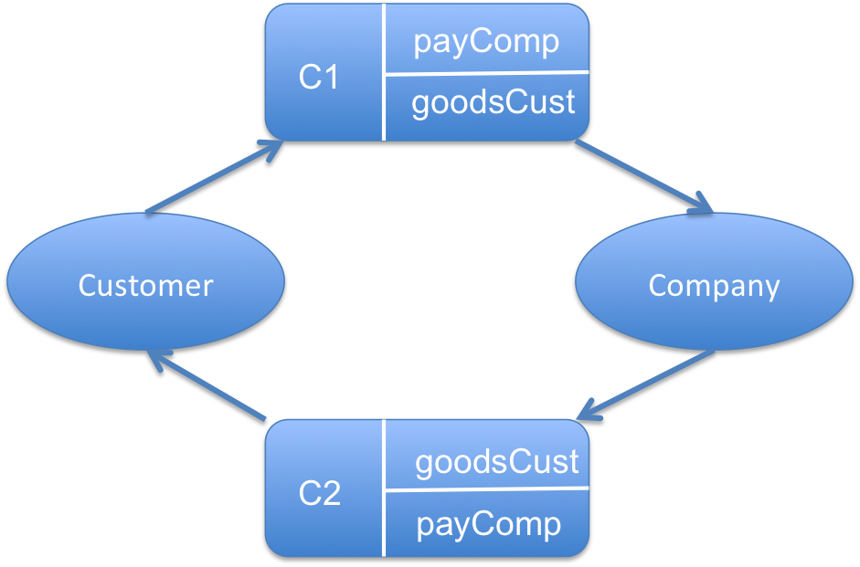

* Sub-scenario 2:

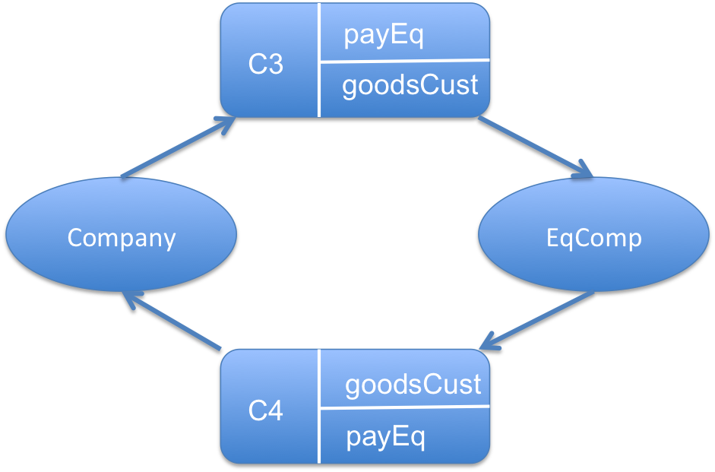

* Sub-scenario 3:

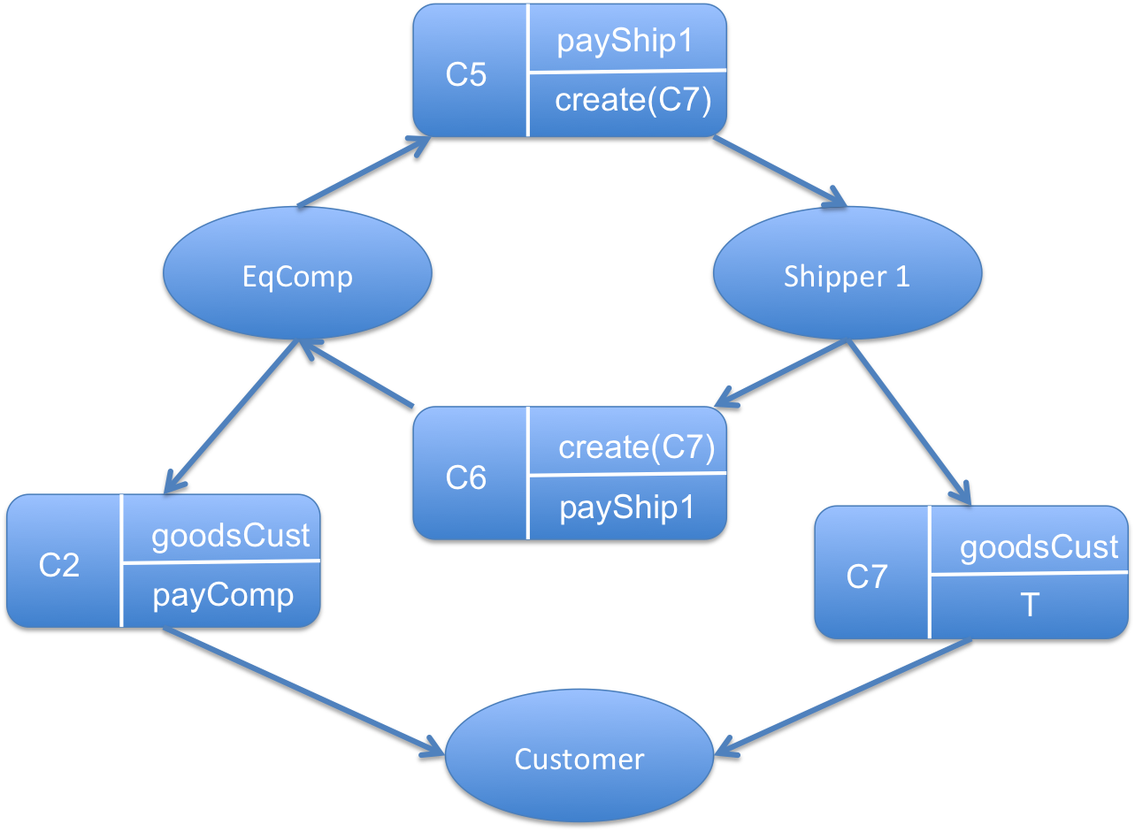

* Sub-scenario 4:

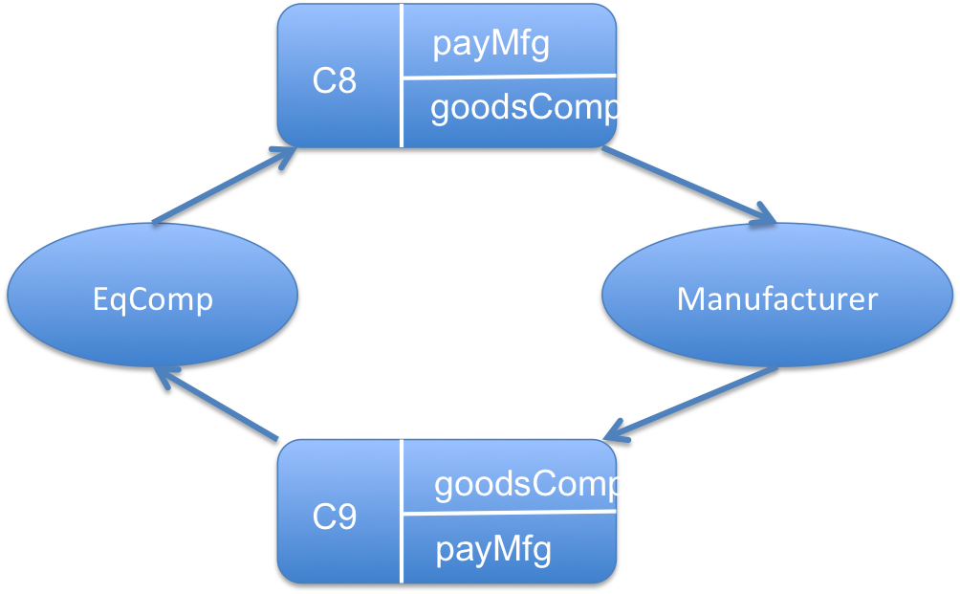

* Sub-scenario 5:

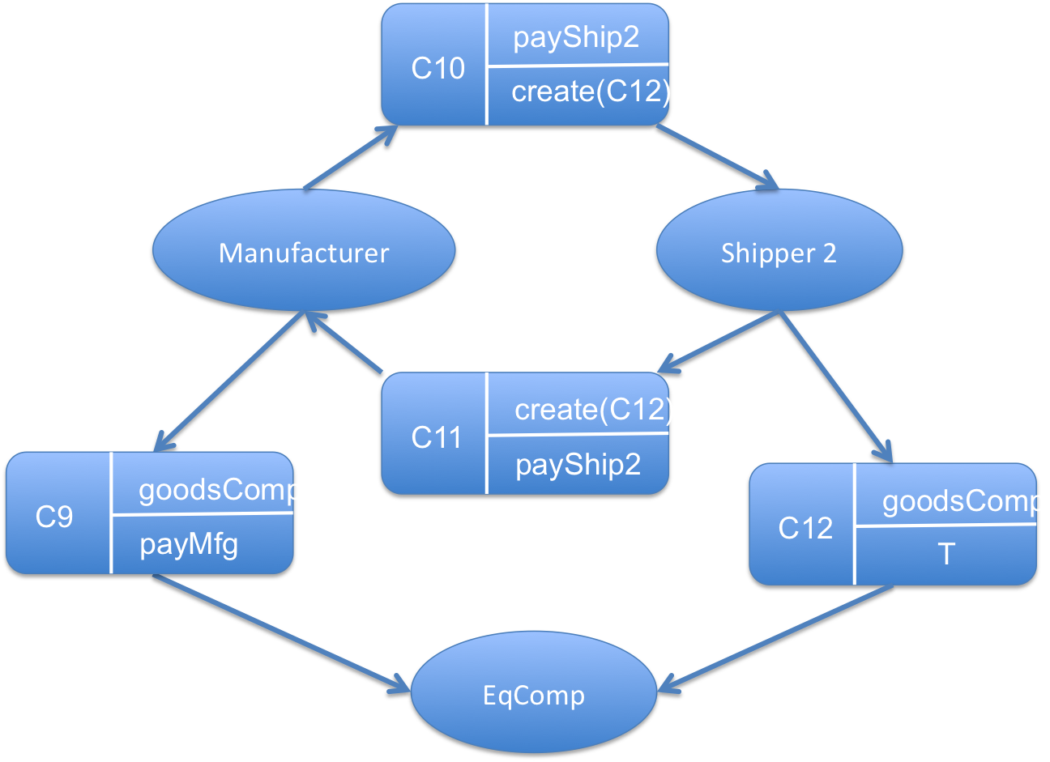

* Sub-scenario 6:

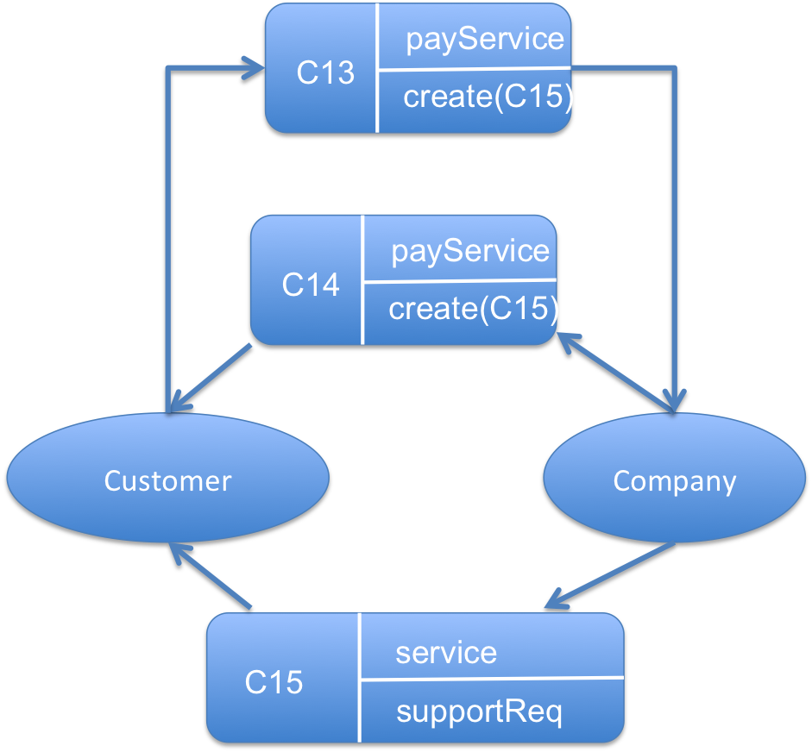

* Business Model:

